***Chemistry notes:***

***Paper 2 – Required Practical’s:***

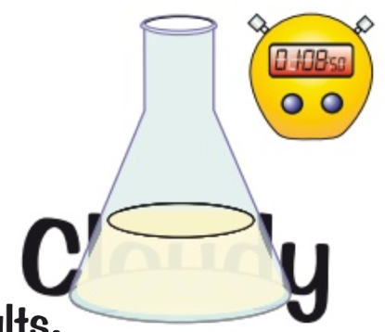**Practical 5 – Measuring Rate of Reaction**

**Precipitation and Colour Change**

**Method:**

1. You can record the visual change in a reaction if:
   1. The initial solution is transparent
   2. The product is a precipitate which clouds the solution (it becomes opaque)
2. You can observe a mark through the solution and measure how long it takes for it to disappear
   1. the faster the mark disappears the quicker the rate of reaction
3. If the reactants are coloured and the products are colourless (or vice versa)
   1. You can time how long it takes for the solution to lose or gain its colour
4. The results are very subjective
   1. Different people might not agree over the exact point where the mark disappears or the solution changes colour
   2. You cannot plot a rate of reaction graph from the results

**Change in mass**

**Method:**

1. Measuring the speed of a reaction that produces a gas can be carried out using a mass balance
2. As the gas is released, the mass disappearing is measured on the balance
3. The quicker the reading on the balance drops, the faster the reaction
4. If the measurements are taken at regular intervals
   1. You can plot a rate of reaction graph and find the rate quite easily
5. The mass balance is very accurate
   1. But it has the disadvantage of releasing the gas straight into the room

**The volume of gas given off**

**Method:**

1. This involves the use of a gas syringe to measure the volume of gas given

**Practical 6 – Paper Chromatography:**

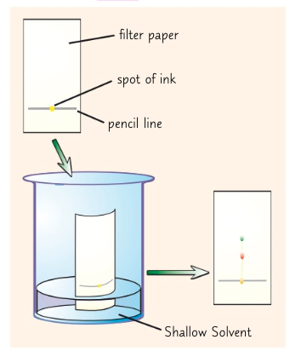Paper Chromatography is used to separate a mixture

**Method:**

1. Draw a line in pencil near the bottom of a sheet of filter paper
2. Add a spot of ink to the line and place the sheet in a solvent
3. The solvent used will depend on what is being tested
   * + - 1. Some compounds dissolve well in water
         2. However sometimes another solvent is needed
4. Make sure the ink isn’t touching the solvent
5. Place a lid on top of the container to stop the solvent evaporating
6. The solvent seeps up the paper, carrying the ink with it
7. Each different dye in the ink will move up the paper at a different rate so the dyes will separate out
   * + - 1. Each dye will form a spot in a different place
8. If it is insoluble it will not move from the line
9. When the solvent has reached the top of the paper, take it out and leave it to dry
10. The end result is a pattern of spots called a chromatogram